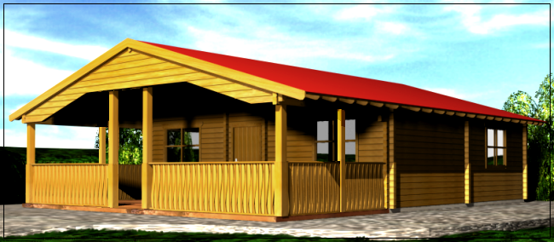

Cottage with Terrace 8.50 m x 10.45 m

Prices:

60 mm: £ 20,387
95 mm: £ 25,502

Consisting of:

Walls: Sturdy 60 mm or 95mm double tongue and groove
8 tightening bars.
Flooring: 28 mm internally, 45mm externally - tongue and groove boards
Roof: 20 mm tongue and groove boards
Roof height: Eves - 2.21 m, Ridge 3.82 m
Living space: 61.1 m² internally, 29.3 m² terrace
Outer doors: 1 unit. 90/200
2 units 140/200
Inner doors: 5 units 89/200
Windows: 3 units 120/94
1 unit 80/94

Extras:

Shutters Call for price
95mm walls instead of 60mm Call for price
Floor and roof isolation Call for price
Roof tiles Call for price

